**Production Search Engine User Manuel**

**Issue No: 2 Date: 08/22/2019**

**Author: Andy (Wei Chieh) Lo**

# Requirements and Installation

* PostgreSQL(version 11.x) Installed with password set as “fortinet”
  1. 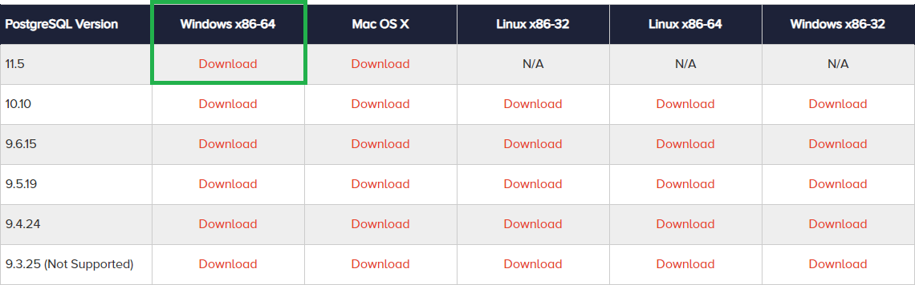Download link: <https://www.enterprisedb.com/downloads/postgres-postgresql-downloads>

Figure 1 PostgreSQL Download Page

2.

* + 1. Run the installation package
    2. Make sure every component is checked

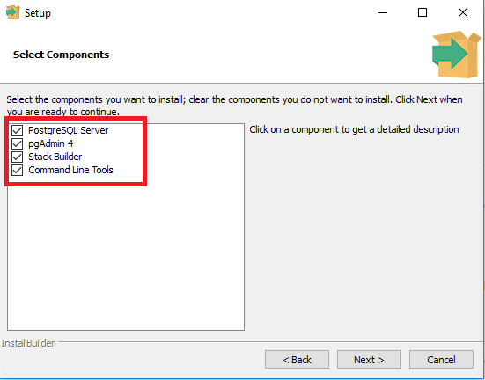

Figure 2 PostgreSQL Setup

* + 1. Enter “fortinet” as the password **Very Important

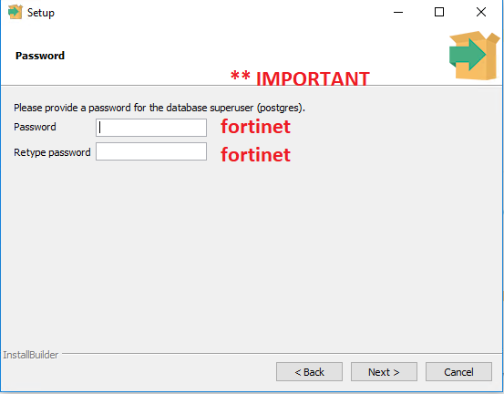

Figure 3 PostgreSQL Setup

* + 1. Finish the installation process with default values

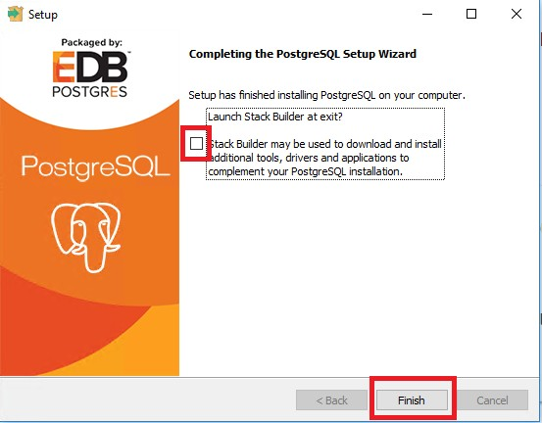

Figure 4 PostgreSQL Setup

1. Execute pgAdmin4

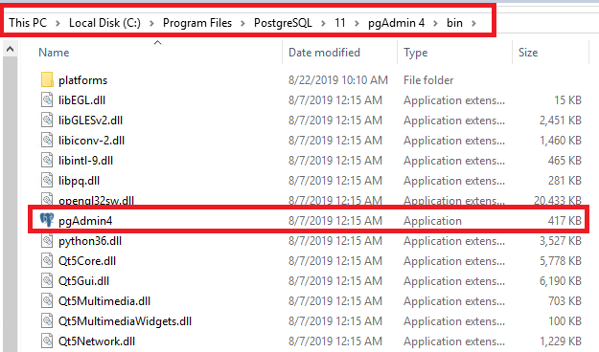

Figure 5 PostgreSQL Setup

1. Set the master password to “fortinet”

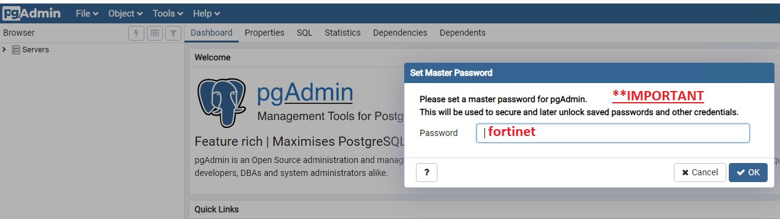

Figure 6 PostgreSQL Setup

1. Installation Done

### Functions:

**Overview**

* Parse CM(.tgz)/IQC(.log) info base on the regex is given by the user
* Create customizable table with user’s preference
* Data analysis graphs
  + Sensor vs Sensor reading distribution bar graph
  + Blacklist keyword distribution bar graph
  + Sensor vs Sensor Scatter Graph (heat map)
  + Sensor vs Sensor Horizontal Graph

**Data Parsing/ Database Creation (Tab 1)**

1. The database will be created based on the csv file, the csv file is in the same directory as the program named “database_create_info”
2. In SearchEngine V 3.6 or later, we have an option to restore a database (Refer to How to load data base section)
3. **database_create_info** can be create/edit manually or with the Search Engine

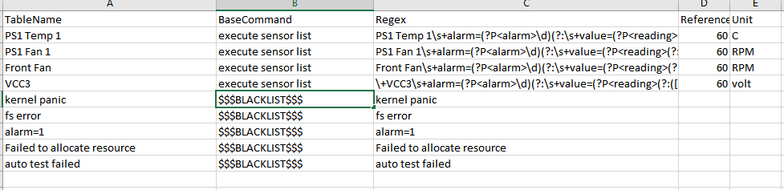

Figure 7 Sample database_create_info

### Search Engine tab 1 columns explain

* 1. Key points:
     1. For Regex, sensor table must have ?P<reading> tag
     2. For Base Command, in order to differentiate between blacklist and sensor, we use $$$BLACKLSIT$$$ for all blacklist
     3. If the “,” is part of the regular expression, please have a double quote around the whole regular expression.

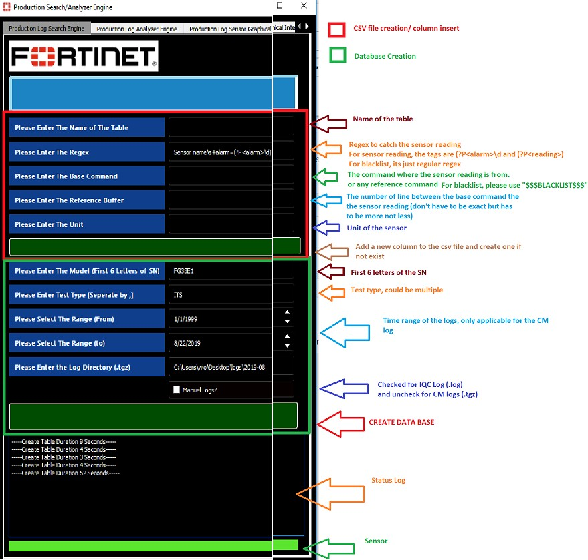

Figure 8 Original Database Creation Page

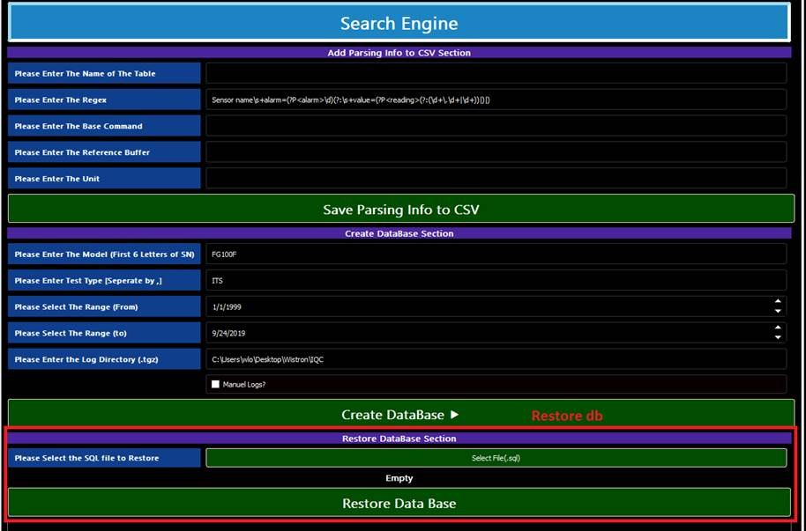

Figure 9 Database Creation Page with Restore db feature

**Customize User View for the Graph (Tab 2)**

1. This tab is used for creating user defined table and the graphical analysis.

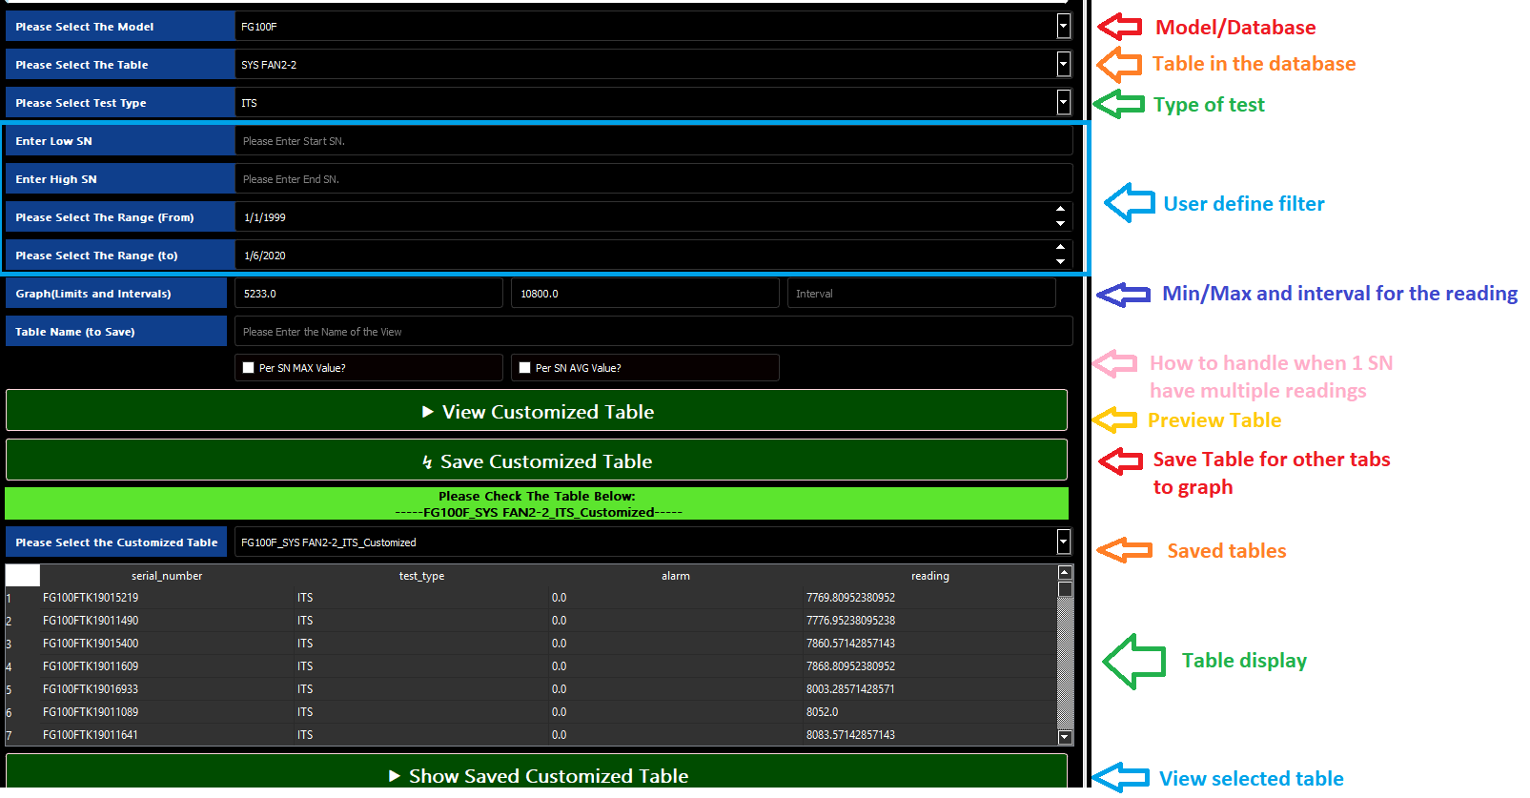

Figure 10 Create custom table page

**Bar Graph for the sensors (Tab 3)**

Order of operations

1. **Create customized table on tab 2 with low/high limit and an interval.**
2. **Click “Add to Graph” to add the graph (Can add up to 3 ) **When graphing more than 2, low/high/interval must be the same**
3. **Click “Graph” to graph the tables selected**
4. **Click “Export” to export an csv files with serial number (the zip file would be in the same directory as the program)**

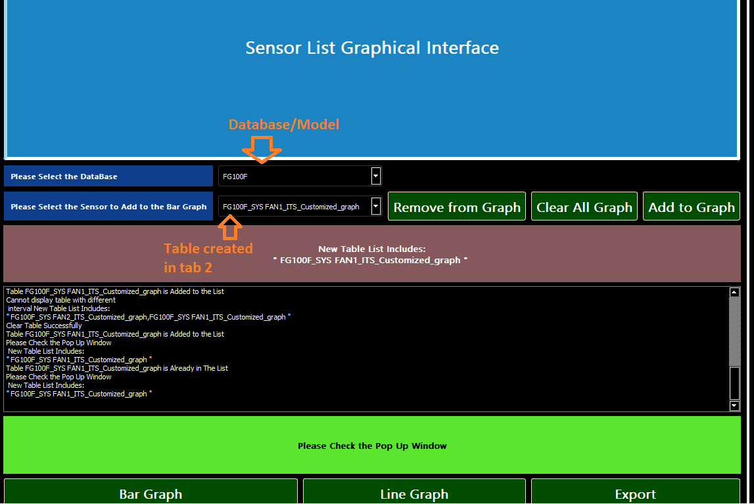

Figure 11 Sensor List Graphical Interface

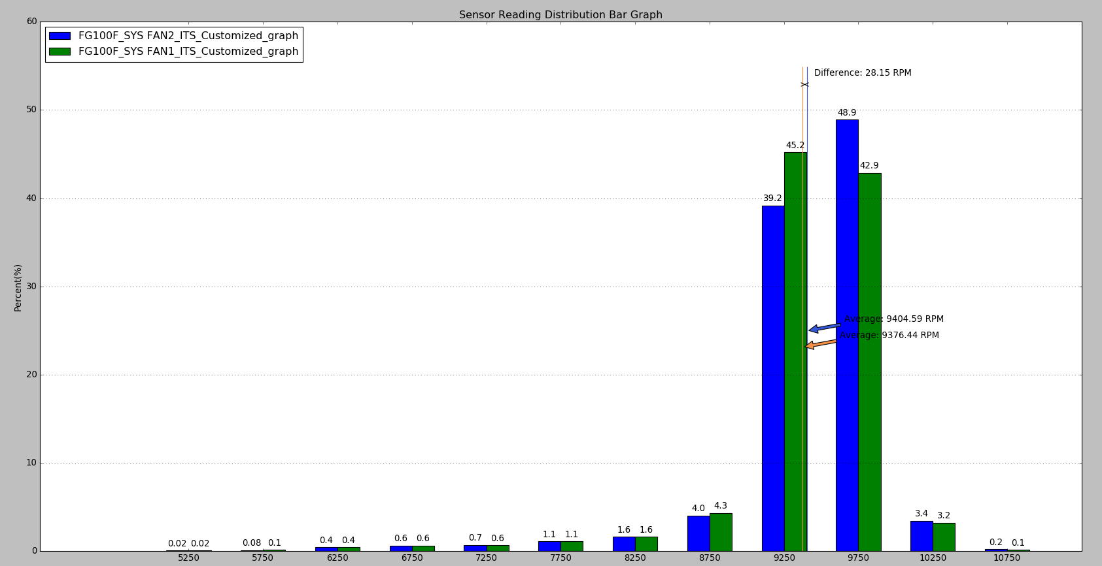

Figure 12 Bar Graph (Tab 3)

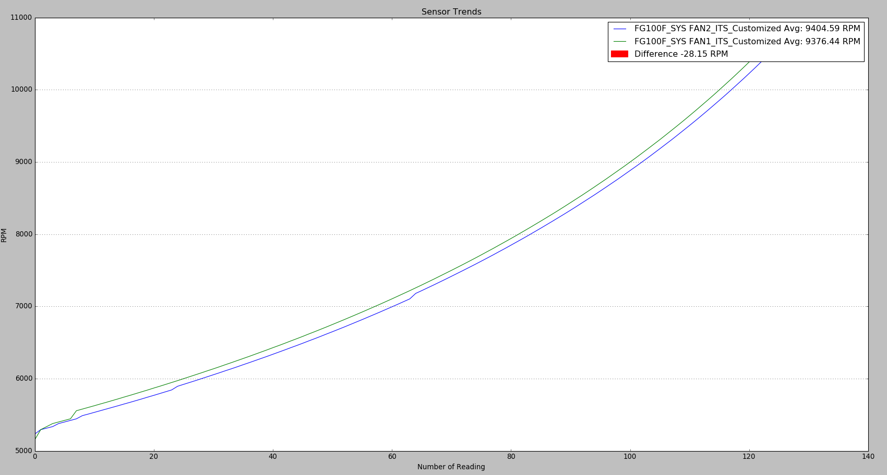

Figure 13 Line Graph (Tab 3)

**Bar Graph for the sensors (Tab 4)**

1. **“Display All” button would show if the keywords have occurred in the log for all blacklist (Not how many time per log, as long as the blacklist keyword is in the log, it counts as 1)**
2. **“Display Filter” button displays the occurrence of a blacklist keyword PER log**
3. **Click “Export” to export an csv files with serial number (the zip file would be in the same directory as the program)**

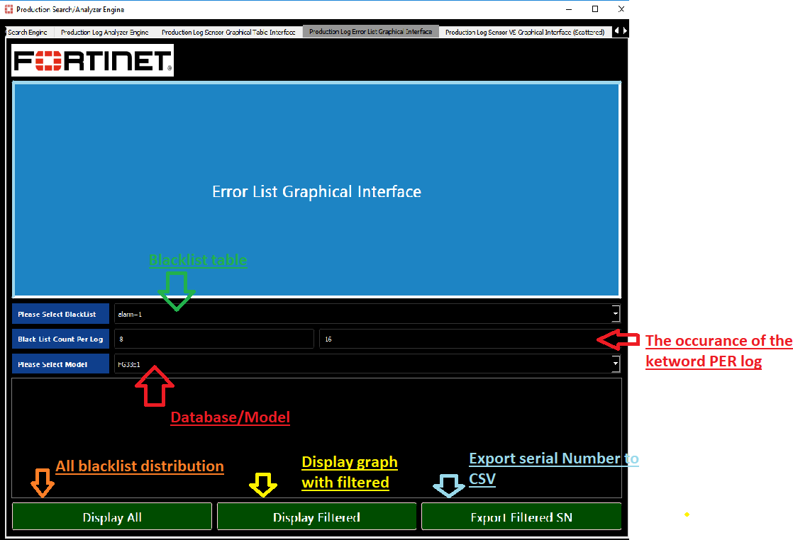

Figure 14 Error List Graphical Interface

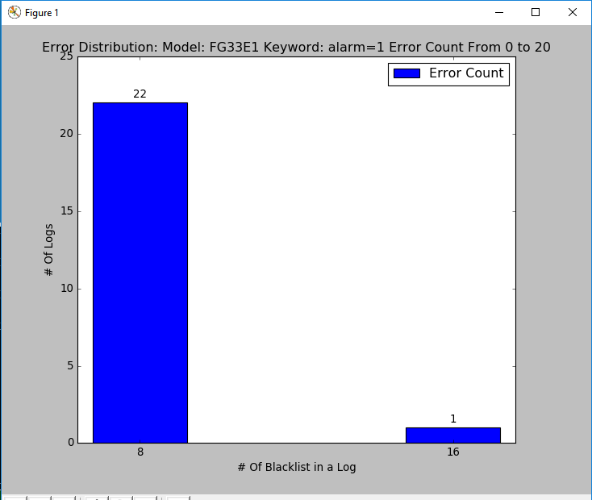

Figure 16 Error Distribution graph

## Scattered Graph for the sensors (Tab 5)

Overview:

The relationship between 2 sensors represent by the line graph and heat map.

Order of operations:

1. **Select the desire filter criteria and then press “Create Table”**
2. **Click “Graph Relationship/Graph Difference/Graph Scatter” to graph the table selected**
3. **Click “Export” to export an csv files with serial number (the zip file would be in the same directory as the program)**

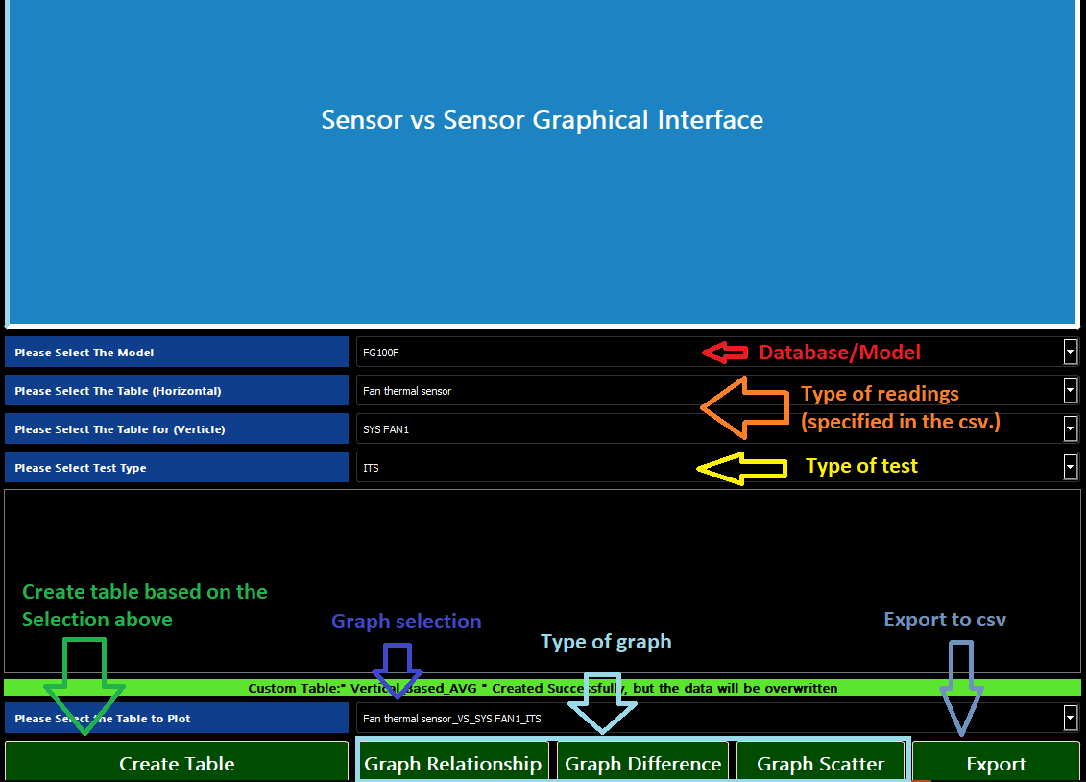

Figure 17

Graph Relationship

Explanation: There are around 3500 logs. “Fan thermal sensor_reading” is sorted, “External thermal sensor_reading” is graphed based on the same reading output as “Fan thermal sensor_reading”

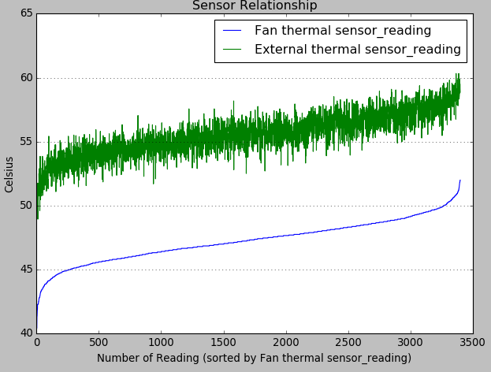

Figure 18 Sensors Relationship Graph

Graph Difference

Explanation: The difference between Fan thermal sensor_reading” and “External thermal sensor_reading”

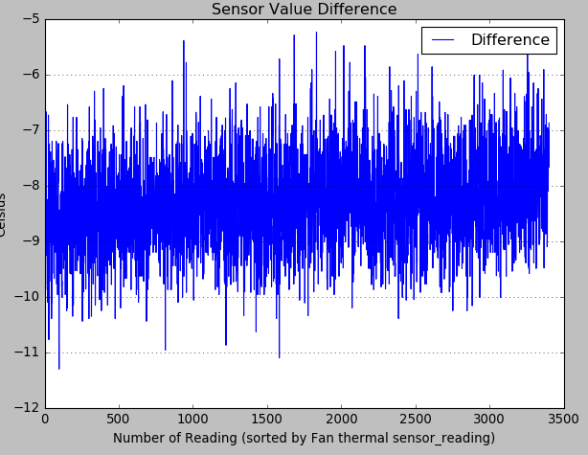

Figure 19 Sensor Difference Graph

Graph Scatter

Explanation: represented 2 readings as heat map, the more concentrated, the redder it gets.

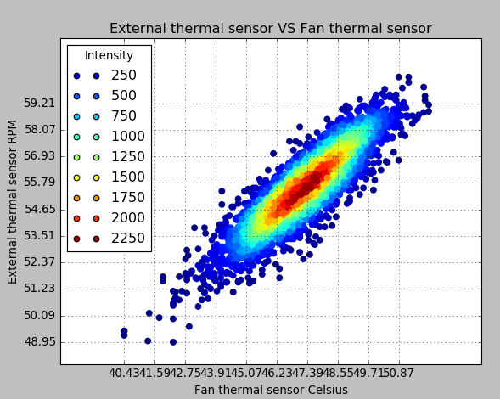

Figure 20 reading distributions present as heat map

## Horizontal Graph for the sensors (Tab 6)

Overview:

The relationship between 2 sensors represent in a certain range Order operations:

1. **Select the desire filter criteria**
2. **Click “Graph” to graph the table selected**
3. **Click “Export” to export an csv files with serial number (the zip file would be in the same directory as the program)**

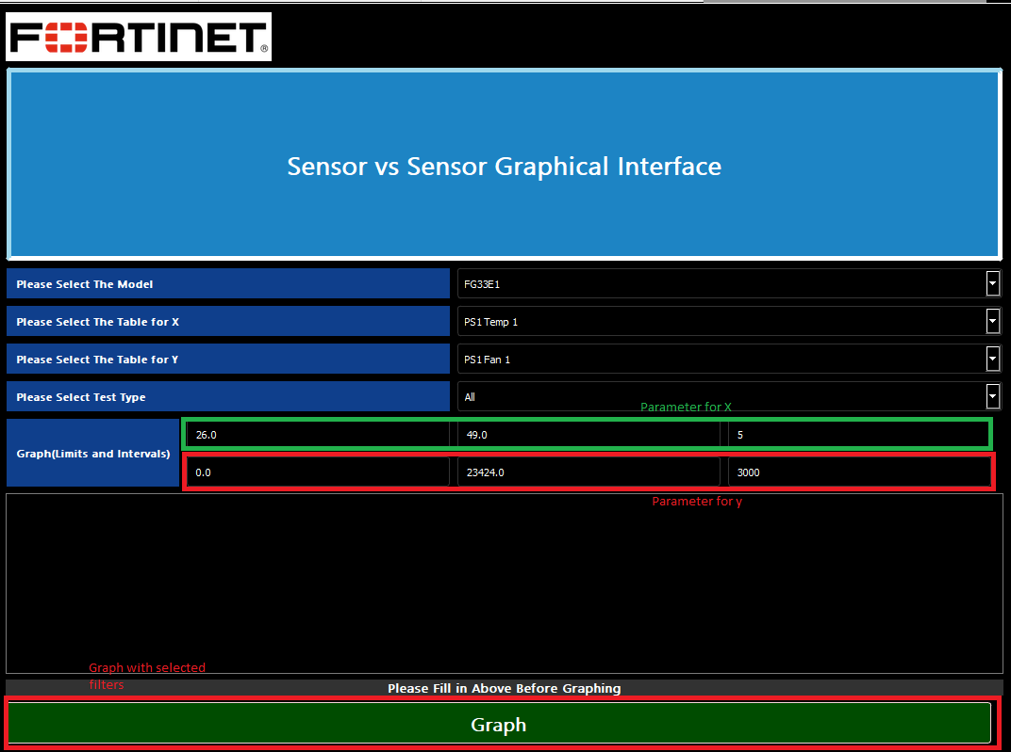

Figure 21 Sensor vs Sensor Graphical Interface

Horizontal Graph

Explanation: The graph represents how “SYS FAN1” reading is distributed based on the user defined “CUP ON-DIE thermal sensor” interval.

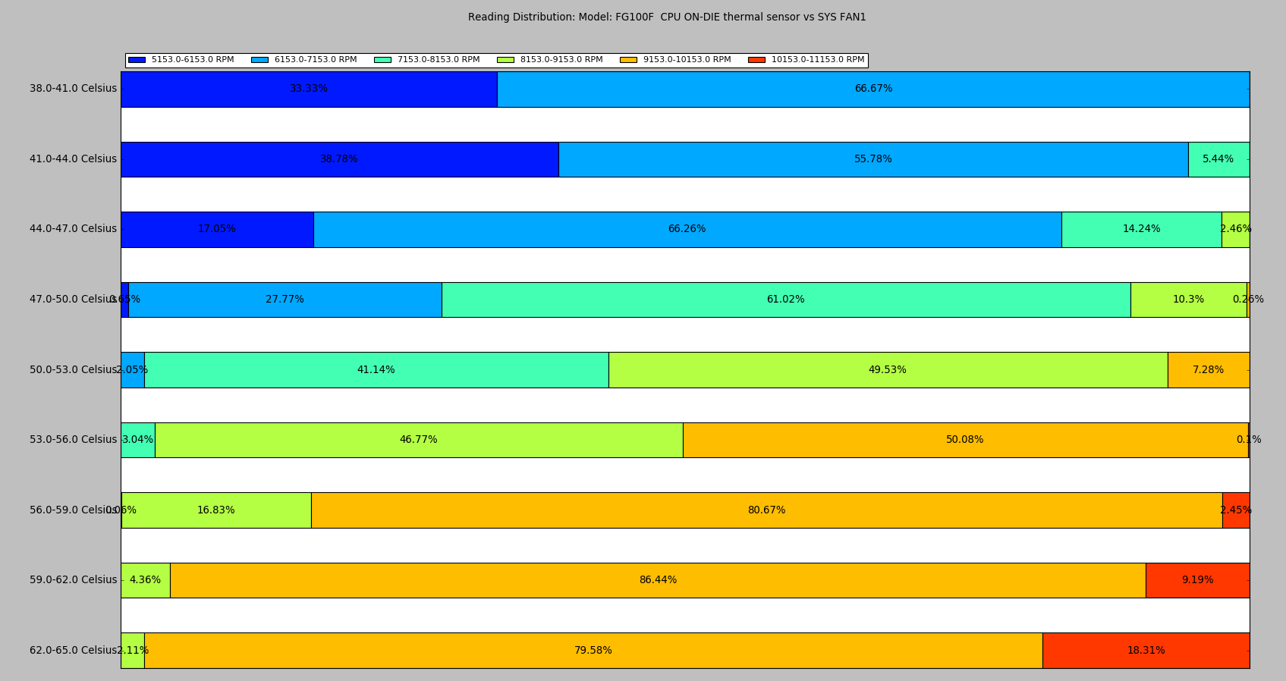

Figure 22 Horizontal graph for sensors relationship

## How to save data base

1. Execute pgAdmin4



Figure 23 Backup data instruction

1. Log in password to “fortinet”
2. Click on Backup on the database you want to back up.

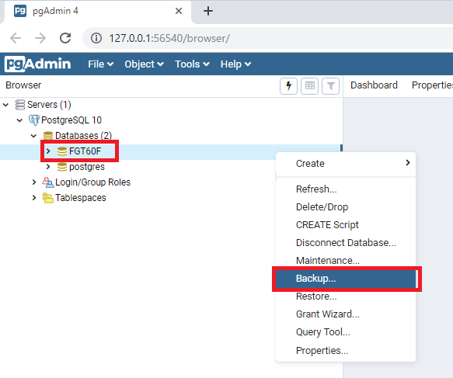

Click on

to select the folder to save in.

### 4.

5. Enter first 6 letters of the serial number + .sql and press create

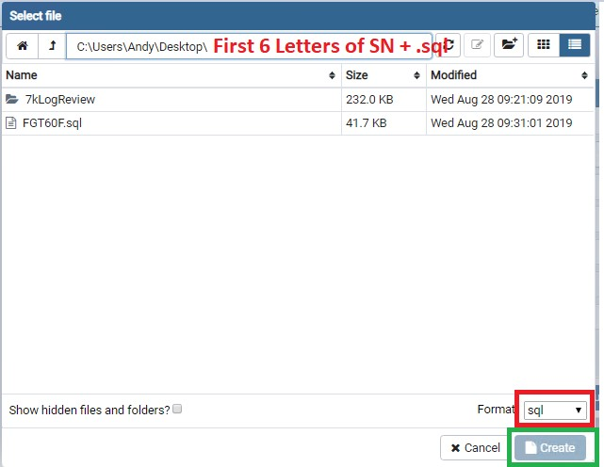

### Figure 23 Backup data instruction

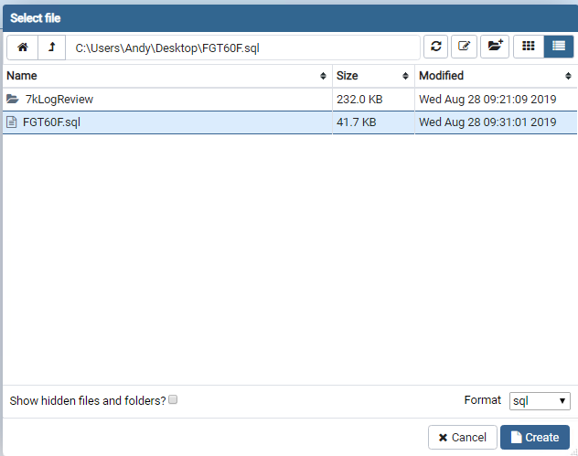

### Figure 24 Backup data instruction

7. Click on “Backup”

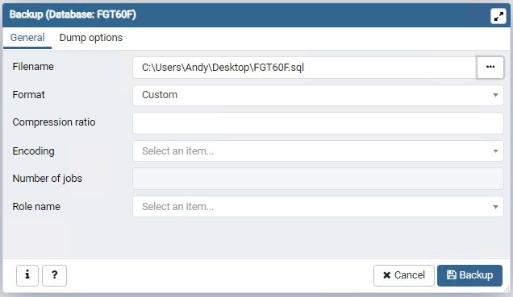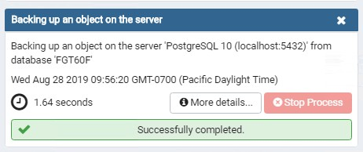

### Figure 25 Backup data instruction